**Add-LocalGroupMember Custom Tool Setup Instructions**

1. In System Frontier, click **Settings.**
2. Click **Custom Fields**. For this tool you will need to set up 1 additional Custom Field.

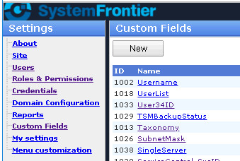

1. Click **New**.
2. The **New Custom Field** form will be displayed.

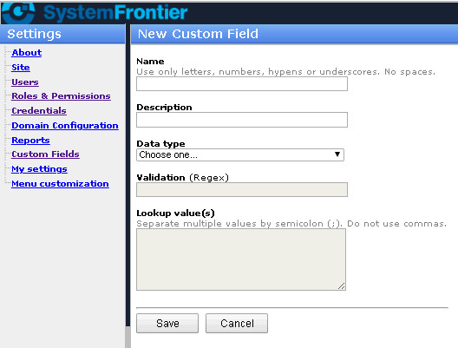

1. Enter the name:

**LocalGroupName**

1. Enter the description:

**Enter the name of the local group that exists on the computer**

1. Choose a Data type of **text**.
2. Click **Save**.
3. Repeat steps 1-8 using this information:

Name: **LocalGroupName**

Description: **Enter either local account name or domain account name with this format (domain\accountname or accountname@domain)**

Data type: **text**

1. Click **Save**.
2. In System Frontier, click on **Tools >** **Create tool**.

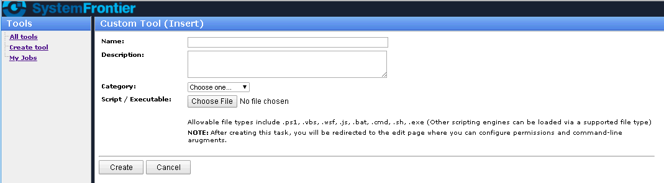

1. Enter the tool name:

**Add-LocalGroupMember**

1. Enter the description:

**Adds a user or group to a local group on a computer.**

1. Select the appropriate category, then click **Choose File** to specify the applicable script to use for this tool. Be sure to select this file:

**Add-LocalGroupMember.ps1**

1. Click **Create**.
2. Once the tool is created, it will open up the **Custom Tool (Edit)** page.

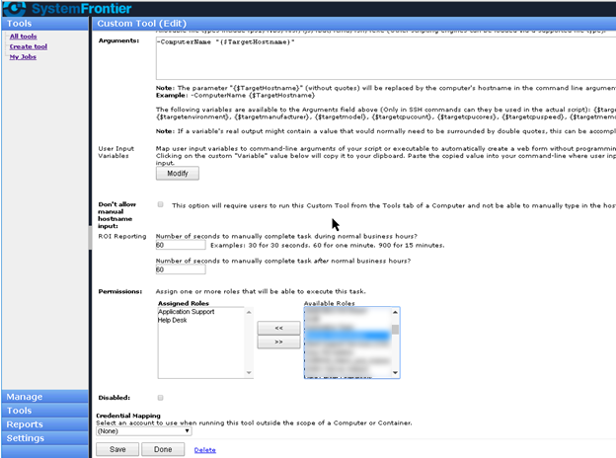

1. Click **Modify**.
2. The **Custom Tool Input** page will be displayed.

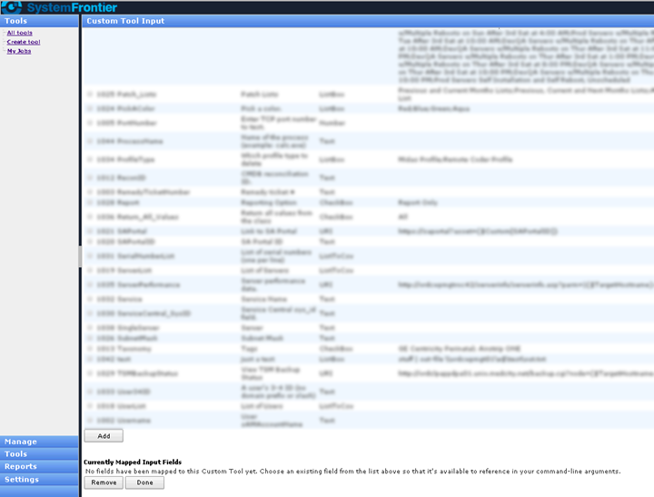

1. Select **LocalGroupName** and **AccountName**.
2. Click **Add**.
3. You will see **LocalGroupName** and **AccountName** appear under **Currently Mapped Input Fields**.

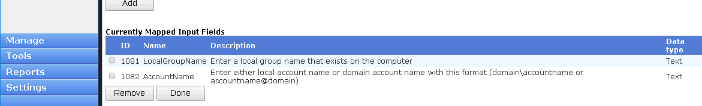

1. Click **Done**.
2. You will be returned to the **Custom Tool (Edit)** page. Scroll down to the Arguments section.

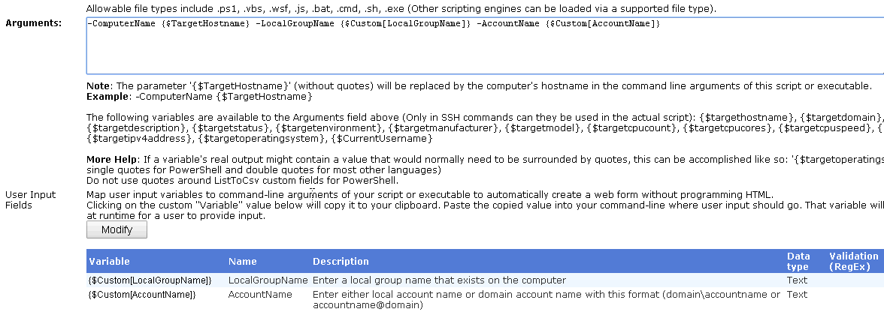

For this tool, 2 arguments are required. Within the Arguments field, type:

**-ComputerName "{$TargetHostname}" -LocalGroupName "{$Custom[LocalGroupName]}" -LocalGroupName "{$Custom[LocalGroupName]}"**

1. Scroll down to the **Permissions** section.

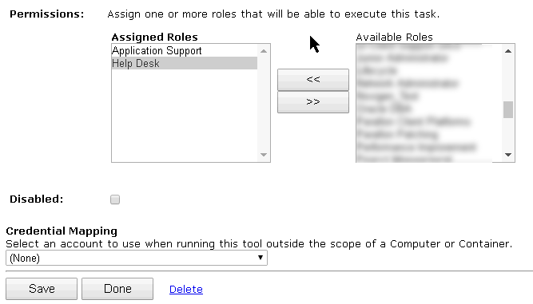

1. Select the **Assigned Roles**. The roles selected will have access to run this tool.
2. Click **Save**.

The setup and configuration for this custom tool is complete.